Mark Kardash

Scroll to Page 18 for revised testing from 2/23/2023

Scroll to Page 11 for revised testing from 2/11/2023

In all honesty, I had terrible difficulties with the program for Week 3, and I knew this was not going to go well. I encountered an error as soon as I launched pylint. It seemed that parsing had failed since early on in the code.



After making a small change, I was met with a plethora of errors, and a shocking score of 0/10.00

I changed the ‘variable_initiation’ function name to ‘__init__’. However, this did not seem to affect the score.

I eventually realized that I had imported many things incorrectly, and did not use some of my variables.

Rewriting some functions gave me my first “climb”, as score of 1.35/10.00

I realized that my experiment with combining elements from different types of data structures had failed. Frankly, I was very nervous, and very confused regarding the difference between lists, tuples, and dictionaries. I decided to rearrange my list to include both brackets and parentheses, as well as append each entry to the list individually. However, I knew this was going to take long, and I had less than an hour before the deadline, so I decided to ask for an extension, and decided to call it a day, with the hopes of having a clearer mind after a good night’s sleep.

Day 2:

On the second day, I saw that I still had a lot of undefined and unused variables. I realized I had overcomplicated my code without a reason. So I started cleaning it up.

My biggest problem at the time seemed to be that the links to the flower pictures were making a lot of lines too long. Rearranging some of the links gave me a score of 3.42/10.00

I shortened some more links, and got 3.77/10.00

My first big breakthrough occurred when I got a 7.77/10.00, after finally fixing the last of the long lines, and removing some unused code.

My score was now 8.75/10.00

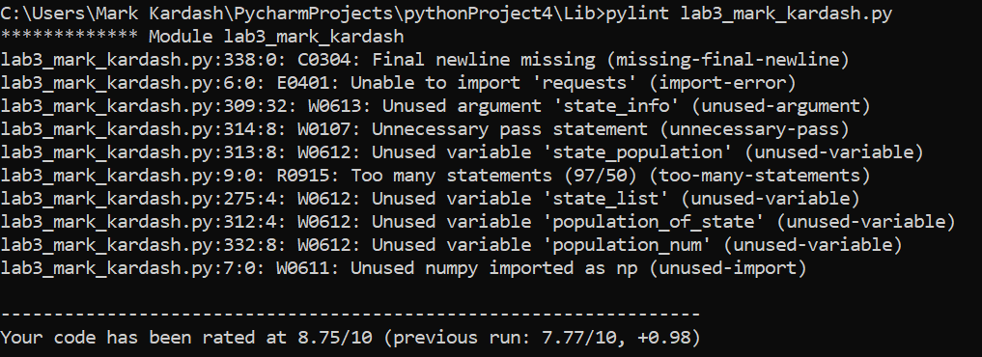

A fix of an issue created an extra unused variable, decreasing my score by 0.05.

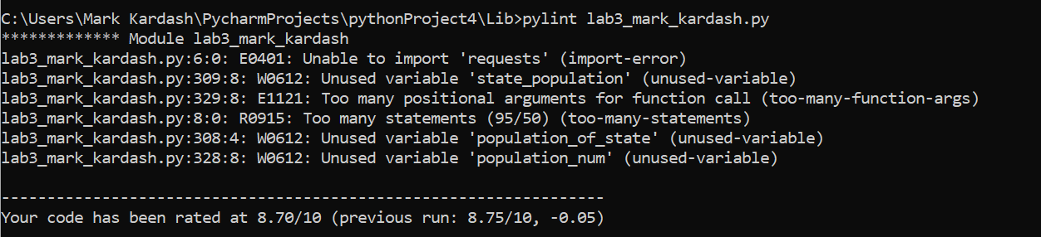

Finally, after eliminating almost all unused variables, I got much closer to 10, with a score of 9.18/10.00

All this time, I had been wondering as to why I couldn’t import the requests option. I checked the error and found out it was not built in, so I had to install it.

My code was scored at 9.55, and then peaked at 9.64. All I had now was a self-assigned variable, an unused argument, an unused variable, and a problem with the option menu, which I had implemented as a function. It now said there were too many statements in it. I tried splitting it into two functions, to see if that would resolve the issue. When it gave no result, I decided to simply place the menu options as separate print statements.

This is when the really bizarre things started happening. I received more errors than I had before, with the score decreasing to 8.89/10.00. Some of them were about missing function docstrings. However, most of them seemed to indicate that my variables had somehow been “redefined”.

Fixing the missing docstrings gave me a score of 9.17, and then of 9.35. Unfortunately, this was my final score, as I did not know how to fix the “redefined” error.

Test Cases:

|  |  |  |  |  |
| --- | --- | --- | --- | --- |
| Test Case: | Input: | Expected Output: | Actual Output: | Pass? |
|  | 1 | Program displays all states in alphabetical order, with capitals, populations and flowers: | Program displays only the names “State: “, “Capital: “, “Population: “, and “Flower: “, with a TypeError: ‘int’ object is not iterable. | No |
|  | 2 | Program allows user to search for a specific state, asking for the name. It then displays state data (Name, capital, etc.), along with a picture of the state flower. | Program asks for state 2 times, image of flower pops up, and, upon closing the image, program generates error “list index out of range”. | No |
|  | 3 | Program displays bar graph with overall state population of 5 most populated states. | Error: “Object ‘int’ is not iterable” | No |
|  | 4 | Program asks for a state name, gives the prompt to update population, and updates population for particular state. | Program asks for a state, prompts to update population, but then gives out ‘list’ object has no attribute ‘state_name’ error. | No |
|  | 5 | The program exits with the message, “Thank you for using our program! Goodbye!” | The program exits with the message, “Thank you for using our program! Goodbye!” | Yes |
|  |  |  |  |  |

Test Case 1 Screenshot:

Test Case 2 Screenshot:

Test Case 3 Screenshot:

Test Case 4 Screenshot:

Test Case 5 Screenshot:

Conclusions:

That…was a bust. Honestly, I struggled incredibly with this. I am EXTREMELY surprised that at least the final test case actually PASSED. I think my main problem was that I couldn’t decide which data structure to use for the project, and kept experimenting with elements from various ones. By the end of the deadline, I was too nervous and exhausted to try and reverse anything. The extra day did not do much, as I was more focused on getting a perfect pylint score rather than actually making the program work. I resolve to try better next time.

Revised Results:

Pylint:

Well, to be fair, I did MUCH better this time. My program mostly works, besides not displaying the flower image, which I didn’t figure out how to do. I purposefully went through the program before running Pylint to try and fix as many formatting issues as possible. However, my first Pylint score for the revised program was 5.98/10.00, and this was mostly due to indentation errors. Frankly, I suspected this was going to be an issue. The indentations that my PyCharm was choosing for me on this assignment seemed very odd, and did not match anything I did before, so I manually corrected them to the way I knew, because that just seemed right. It looks like now I am going to have to correct everything back to the way it was.

After fixing most of the mistakes, I was absolutely baffled to receive a score of 4.76/10.00, once again mostly due to bad indentation. I thought that correcting the indents to what PyCharm had suggested would fix things, but it seemed to have no effect. I was now determined to find the problem.

After paying close attention to how many spaces were required for each indent, I once again corrected the code. I initially had an “unexpected indent” error.



Then I had a few “Bad indentation” errors from fixing that, but still had a score of 9.17/10.00

Parsing error again:



Indent errors! Again! Score of 8.81/10.00

Finally, after a few more tweaks, my score was a perfect one.

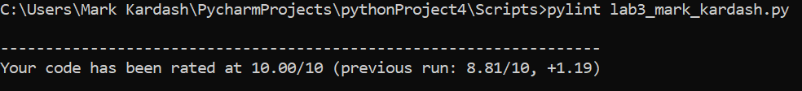

Revised Test Cases:

|  |  |  |  |  |
| --- | --- | --- | --- | --- |
| Test Case: | Input (In Order): | Expected Output: | Actual Output: | Pass? |
|  | 1 | The data for all 50 states (Name, Capital, Population, and Flower, are displayed in a table. | The data for all 50 states (Name, Capital, Population, and Flower, are displayed in a table. | Yes |
|  | 2, Alabama | The program prompts the user to select a state, and then prints the data for that particular state, along with the image of the state flower. | The program prompts the user for a state, prints the header twice, then prints the corresponding data, but DOES NOT display the image, instead showing a “Keyerror” error message. | No |
|  | 3 | Program displays a graph of the 5 most populated states. | Program displays a graph of the 5 most populated states. | Yes |
|  | 4, Maryland | The program prompts the user for the state updates the population of Maryland to the new number. | Population successfully updated (Screenshots below for comparison).  However, the program does still display the image error. | Yes |
|  | 5 | “Thank you for using our program. Goodbye!” message is displayed as the program exits. | “Thank you for using our program. Goodbye!” message is displayed as the program exits. | Yes |

Test Case 1 Screenshot:



Test Case 2 Screenshot:

Test Case 3 Screenshot:

Test Case 4 Part A Screenshot:

Maryland population before.

Test case result:

Test Case 4 Part B Screenshot:

Maryland population check.

Test Case 5 Screenshot:

Updated Conclusion:

A much, much better. result this time. Mostly because I didn’t have a deadline that catastrophically close as I did when first submitting this. I tried a couple of ways to get the image to display, but ultimately failed. Felt I was close, but was missing something.

Revised Results (Again) (2/23/2023):

I have finally managed to get the flower images to display, making my program work perfectly. Let us start with the pylint results.

Pylint Testing:

My first official Pylint run gave me a score of 7.88/10. I had been previously using pylint while coding, so that I avoid basic mistakes, which is why it shows a previous result. My sole mistakes were lines that were too long, with the urls of the state flowers. I therefore set out to correct them.

This landed my code a perfect score.

Test Cases:

I was not worried about the test cases at all, since I only changed the function calling the image, with the rest of the program remaining virtually unchanged. I ran the exact same test cases all over again.

|  |  |  |  |  |
| --- | --- | --- | --- | --- |
| Test Case: | Input (In Order): | Expected Output: | Actual Output: | Pass? |
|  | 1 | The data for all 50 states (Name, Capital, Population, and Flower, are displayed in a table. | The data for all 50 states (Name, Capital, Population, and Flower, are displayed in a table. | Yes |
|  | 2, Alabama | The program prompts the user to select a state, and then prints the data for that particular state, along with the image of the state flower. | The program prompts the user to select a state, and then prints the data for that particular state, along with the image of the state flower. | Yes |
|  | 3 | Program displays a graph of the 5 most populated states. | Program displays a graph of the 5 most populated states. | Yes |
|  | 4, Maryland | The program prompts the user for the state updates the population of Maryland to the new number (In my case, 7,000,000) | Population successfully updated (Screenshots below for comparison). | Yes |
|  | 5 | “Thank you for using our program. Goodbye!” message is displayed as the program exits. | “Thank you for using our program. Goodbye!” message is displayed as the program exits. | Yes |

Test Case 1 Screenshot:

Test Case 2 Screenshot:

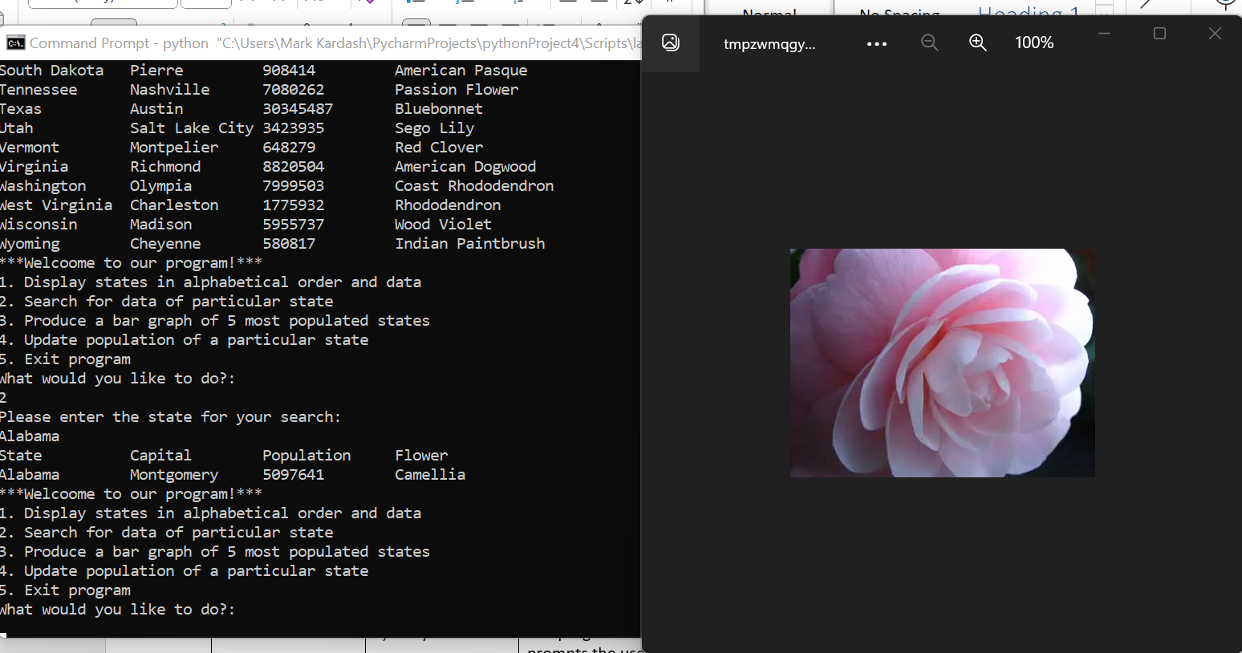

Test Case 3 Screenshot:

Test Case 4 Screenshots:

Before update:

After update:

Test Case 5 Screenshot:

Conclusion:

It took me quite a while to figure out how to display the images on the screen, but once I did it, the program worked perfectly, without a single error. I can now say I’m officially done with it, after seeing that perseverance and enough time can get us the desired result.